**Research Description**

In hospitals, narcotics are primarily administered to patients in the operating rooms (ORs) and on patient care floors. Often times, a full dose of narcotic is not required for optimal treatment, so the residual volume left in the syringe must be carefully documented and disposed of [1]. Based on initial data obtained from pharmacy directors, hospitals in the US generate at least 120 million of these partial dose wastes from their ORs alone each year. Unfortunately, the lack of effective narcotic waste security has led to its abuse by hospital professionals, contributing heavily to the estimated 10-15% of healthcare professionals that struggle with addiction at a point in their careers [2]. Commonly, addicted practitioners abuse narcotics by injecting themselves with the unused portion of narcotic and replacing that volume with an equal amount of water or saline. To combat this threat, some hospital pharmacists use refractometers to audit random waste samples, but this technique is unreliable due to its inability to even distinguish water from the ultrapotent narcotic, fentanyl [3]. Accordingly, there is an immediate need for a system capable of accurately analyzing the concentration and identity of hospital narcotic waste. To provide a comprehensive defense against drug abuse, the system would also detect the waste volume, digitally synchronize waste information with pre-existing pharmacy data records, then chemically-deactivate and secure the narcotic.

To fulfill this immediate need, we propose the further development of a robust, affordable liquid narcotic analysis technique, that is capable of detecting fentanyl in solution down to 10 μg/mL. Implementation of this technique would be a crucial step in reducing the narcotic abuse epidemic in hospitals. We will employ Ultraviolet-Visible (UV-Vis) Spectroscopy with a quartz cuvette to achieve cost-effective and highly-sensitive molecular detection [4]. Other viable techniques, such as Surface-Enhanced Raman Spectroscopy, High Performance, Liquid Chromatography, and Mass Spectrometry, are too expensive and time-consuming for hospital implementation.

Because the characteristic peak absorbance wavelengths for organic molecules, such as narcotics, are often in the ultraviolet range, a quartz cuvette must be utilized, as glass or plastic cuvettes will disrupt the signal. UV-Vis Spectroscopy is a standard laboratory technique that has been used to identify and quantify the concentrations of organic molecule solutions. This technique has tremendous applicability for the development of a high-throughput quantification platform for narcotic waste. Initially, the capabilities of Quartz Cuvette UV-Vis will be tested with solutions of non-controlled pharmaceuticals (e.g. acetaminophen) at concentrations of 5μg/mL to 100mg/mL, to evaluate its ability to detect characteristic signals at standard pharmaceutical dilutions. Subsequently, identical evaluatory protocols will be executed with controlled-substance solutions (e.g. fentanyl, morphine, etc.) at Nemours A.I. Dupont Hospital for Children. Once the method is validated for narcotic analysis, we will build a comprehensive absorbance spectra library for all hospital narcotics, allowing for the automated quantification of all the narcotic waste generated at an institution.

Once the detection platform has been developed, JADE Biotech will incorporate its capabilities into a fully comprehensive narcotic waste management system. The *WasteWell* will quantify the identity and concentration of a disposed narcotic, record the wasted volume, deactivate/secure the waste, and transmit the data to the hospital narcotic inventory records. This system would provide the only quantitative assurance against narcotic waste abuse, while also saving pharmacy personnel valuable time recording and auditing substance disposal data. The ultimate purpose of the WasteWell is to repair the security gaps in narcotic waste disposal, critically reducing the level of narcotic abuse and addiction among hospital personnel.

**Prototype Description**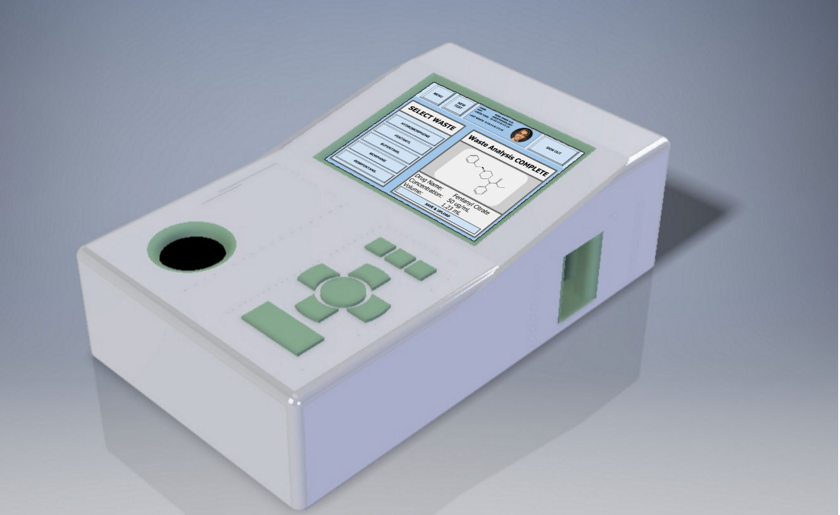

**Features**

The UV-Vis sensory platform yields a characteristic, concentration-dependent optical property shift when analyzing a particular narcotic in solution. Once a full narcotic data library has been developed, the WasteWell will be able to quickly, objectively, and cost-effectively verify the identity and concentration of narcotic substances being wasted, representing significant improvement over current methods of waste handling, where wasting is only confirmed by an often unreliable second “witness” prior to disposal.

The WasteWell will also feature a reservoir for securing the narcotic waste, and rendering it irretrievable, as per the DEA-approved deactivation standards [5]. This will ensure that waste cannot be used for illicit purposes, while also eliminating the need for costly and complicated retrieval by a licensed reverse distributor.

Once the waste has been secured and analyzed, the WasteWell will synchronize wirelessly with a hospital's narcotic inventory management system, allowing for the data from every waste event to be automatically recorded and added to a comprehensive database of narcotic handling activity. Until now, the digital tracking of narcotics in the hospital setting has been constrained to core inventory and patient administration, with almost no attention being given towards securing the amount of waste being generated. The WasteWell analytics platform will replace outdated manual cataloging and auditing processes, closing the digital loop of narcotic tracking in hospitals.

**Implementation Characteristics**

The design of our device was driven by input from 35 pharmacy directors operating in hospital systems across the United States. The WasteWell’s dimensions are analogous to that of a standard shoebox, roughly 12” x 7” x 4”. While still subject to change, this size offers a balance between the efficiencies of a compact form factor, and the benefits of storing a large amount of deactivated narcotic waste, to avoid constant replacement of the waste reservoir.

We envision the WasteWell being placed adjacent to narcotic dispensing cabinets. These cabinets are primarily found in Operating Rooms, as well as Nursing Units located throughout the hospital. Positioning devices in these locations would minimize the distance liquid narcotic waste has to travel before it is efficiently disposed of. Based on qualitative data obtained from customer interviews, we estimate that a given hospital could require anywhere from 15-200 WasteWell units, depending on their size and the amount of narcotic waste generated.

**Usage Summary**

In the Operating Rooms, anesthesiologists and nurse anesthetists administer narcotics at the start of a surgery, and intermittently during a procedure to start and maintain analgesia. On the Nursing Units, nurses will routinely provide scheduled injections of pain medications (e.g. morphine) to patients under their care. As these doses are standardized, and patients’ weights are not, it is common for a portion of the dose to remain in the syringe after patient administration. Any unused narcotic must be immediately disposed of to prevent tampering or theft.

The usage of the WasteWell for performing this wasting will be as follows: A healthcare provider with narcotic waste enters their personal identification number into the device, ensuring wastage accountability. The user selects, from a predefined list of commonly discarded narcotics, the medication he or she is disposing of. The user attaches their syringe via a luer lock adapter to the injection port of the WasteWell, and proceeds to empty the full remaining content of the syringe into the WasteWell. Once this is complete, the empty syringe can be disposed of into a sharps container, and the user is free to return to their duties in the Operating Room or Nursing Unit. We estimate the process taking a practitioner less than thirty seconds per waste, which is a drastic improvement over the current methods that take two staff members roughly five minutes to complete. The WasteWell will take the hassle out of disposing narcotic waste, while drastically improving the security and transparency of the entire wasting process.

**Customer Validation**

The JADE Biotech team has been trained in lean startup methodology, in regards to assessing the commercial viability of a solution to an unmet need. Our customer validation will consist of a series of problem and solution interviews. In the problem interviews, the team will engage target customers (hospital pharmacy directors at mid-to-large sized hospitals in the US) with the goal of developing a greater understanding of the customer ecosystem, as well as the major pain points that they identify as critically important and unmet. Through this process, we will be able to validate our assumptions about the insecurity and inefficiency of narcotic waste handling.

Completion of problem interviews will enable us to refine our existing product concept, which we will then present to past interviewees as part of solution interviews. In these interviews, our goal is to determine whether or not our solution provides benefits that meet the highest-priority needs of our target customers, and to uncover any more improvements for us to address. It is expected that the look, feel, and feature set will change throughout this solution interview process, with each successive iteration converging to the optimal form-factor and feature set desired by the market.

From our preliminary customer interviews, we have strong qualitative evidence to suggest that the hospital pharmacy directors are our target customer. These individuals are given the ultimate responsibility for any gaps in narcotic security in their hospitals, and are the key players in buying decisions surrounding devices that augment the narcotic handling process. In our experience, the most valuable customer interviews are conducted on-site at the hospitals that our customers preside over. We are able to assess the customer's genuine reaction to our solution more effectively, and are able to immerse ourselves further into our customer's environment. This affords us a more complete understanding of the problem space, and enables us to design a product that best addresses the customer’s needs.

Over the next three months, our primary goal is to scale up our customer discovery effort, utilizing resources from the NIDA Challenge and NSF I-Corps Sites programs to travel and meet with the medical professionals responsible for narcotic security. This will help us to ensure that we have a complete understanding of our problem space, and give us clarity on which research aims will be highest priority for our SBIR application. To achieve more complete discovery, we will schedule in-person visits with hospital personnel at hospitals in the Northeast and Midwest regions, with a standing goal of visiting a new system each week from now until January 2017.

JADE Biotech has conducted significant initial research within the hospital pharmacy space, to develop a more comprehensive understanding of the problem. To date, we have met with 35 pharmacy directors, 5 hospital pharmacists, 4 nurses, and 3 anesthesiologists to probe their perspectives on narcotic waste management and uncover the most valuable opportunities for improvement. Our customer discovery process to this point has focused on pharmacy directors, as they are ultimately responsible for gaps in narcotic security, and they have the purchasing power for hospital-wide system implementation. However, we have only reached a fraction of the pharmacy directors and personnel that we are hoping to connect with, and we will continue to engage and learn from our target customers through cold-calls, warm introductions and in-person engagement at pharmacy conventions. Our standing goal is to complete 70 total problem interviews, primarily with pharmacy directors, as well as 25 follow-up solution interviews to ensure that our sample size best reflects the diversity in pharmacy processes across a range of hospitals.

**Technical Competency**

The JADE Biotech team blends effective engineering talent with a wealth of narcotic management expertise. Biomedical engineers **Dan Charytonowicz** and **John Lowman** graduated summa cum laude from the University of Delaware in 2016. Dan was awarded the Barry M. Goldwater Scholarship for excellence in undergraduate research, and was named one of 35 American Gates-Cambridge Scholars. His research has spanned molecular biology, cognitive psychology, and systems biology, co-authoring two papers and completing an honors thesis focused on the modelling of gene expression dynamics. John is a two-time Biomedical Engineering Student of the Year at the University of Delaware, and he developed analytical and pharmaceutical chemistry expertise as a process chemist at Wilmington PharmaTech LLC. John is also adept at developing and validating research methods, skills he gained designing protocol validations and optimizing data collection techniques as a researcher at the University of Delaware.

Anesthesiologist **Dr. B. Randall Brenn** and pharmacist **Dr. Elora Hilmas** are considered two of the top healthcare professionals in the space of drug diversion prevention. Dr. Brenn has been conducting clinical research related to patient care for more than 20 years. His background in informatics allows him to employ large datasets to research clinical questions, and he has over 20 peer-reviewed manuscripts. Dr. Hilmas oversees the research initiatives within the pharmacy department, and has previously worked as a scientist at the Medical Research Institute of Chemical Defense. She has 17 publications, serves as a co-investigator on an NIH-funded trial looking at optimizing drug dosing for pediatric patients, and holds a patent for a computer program that is used by prescribers across the country.

**REFERENCES**

1. Disposal of Controlled Substances by Persons Not Registered With the Drug Enforcement Agency. DEA, Justice. Federal Register. 2009, vol. 74(12), p. 3480-3487
2. Albert, Mike. DEA Pharmaceutical Waste Q&A. Triumverate Environmental. 30 Jan. 2015. Interview.
3. Eagle, CJ.; Maltby JR.; Kryski S.; Hardy D. Use of refractometry to identify opioid-containing solutions. Can. J. Anaesth. 1994, vol. 41(3), p. 248-252
4. Jelinkova, R.; Halamek, E.; Kobliha, Z. The Possibility of Identifying Selected Opioids by Spectral Analysis. Mil. Med. Sci. Lett. (Voj. Zdrav. Listy) 2013, vol. 82(4), p. 172-179 ISSN 0372-7025
5. Disposal of Narcotics Using Activated Carbon. North Carolina Veterinary Medical Board. 2014. PDF.